**Question 1:** A square prism of 30 mm side and 90 mm height is lying on its base on HP such that the edges of the base are equally inclined to VP. The prism is cut by a section plane passing through the mid-point of the axis such that the true shape of the section is a rhombus of larger diagonal of 70 mm. Draw the sectional top view, true shape of the section.

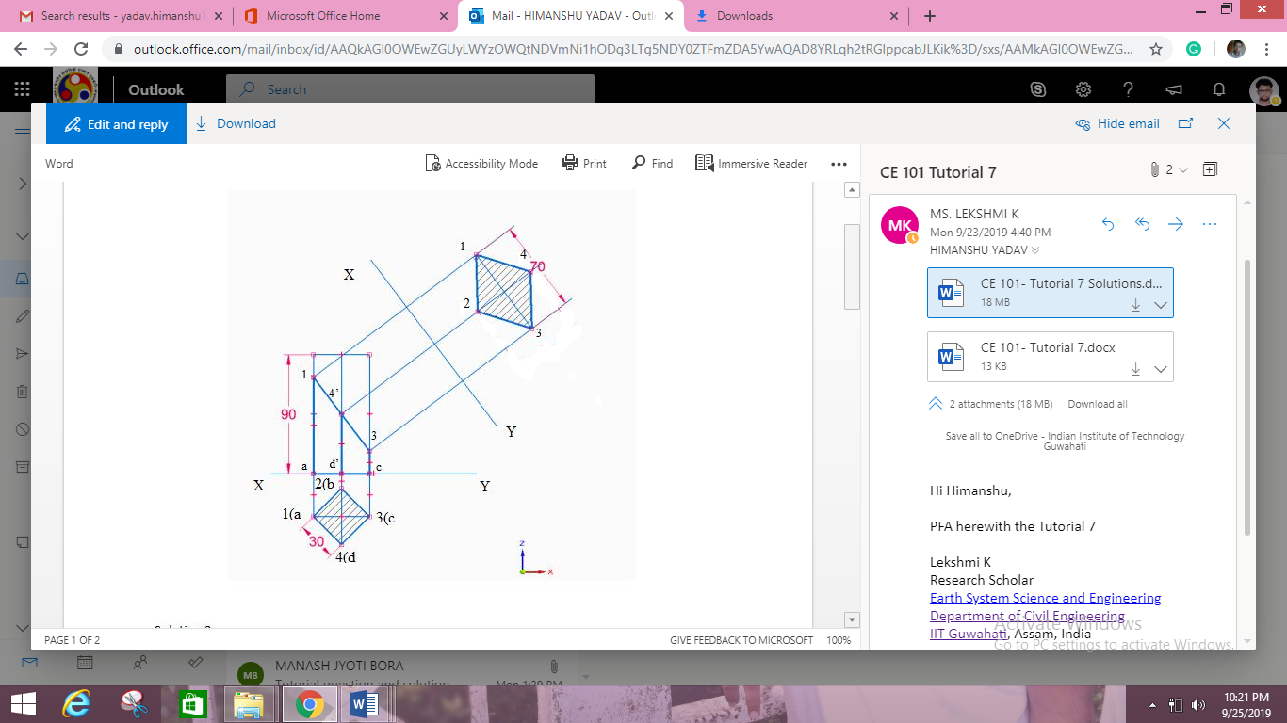

**Question 2:** A Hexagonal prism has a face on the H.P. and the axis parallel to the V.P. It is cut by a section plane which makes an angle of 45o with VP and which cuts the axis at a point 20 mm from one of its ends along the central line. Draw its sectional front view and the true shape of the section. Side of base 30 mm long height 60mm.

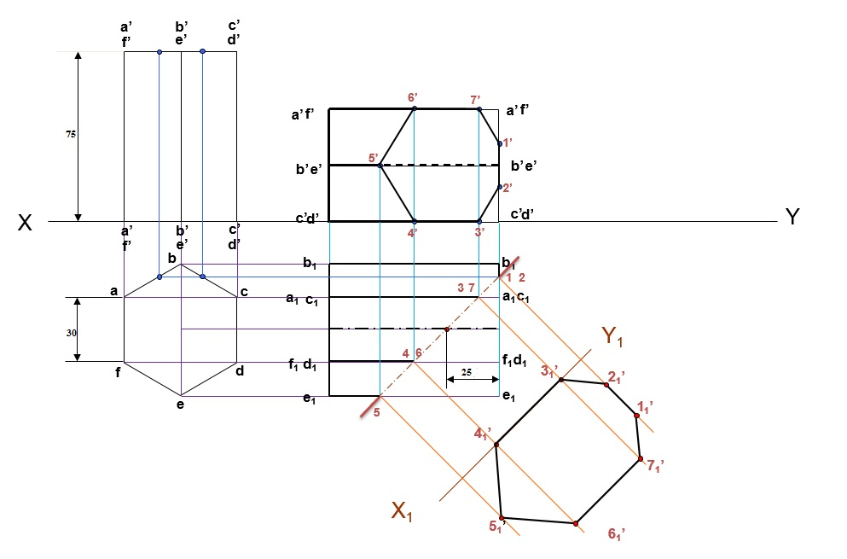

**Question 3:** A square pyramid, base 45 mm side and axis 75 mm long, has its base on the HP and all the edges of the base equally inclined to the VP. It is cut by a section plane, perpendicular to the VP, inclined at 55° to the HP and bisecting the axis. Draw its sectional top view, sectional side view and true shape of the section.

